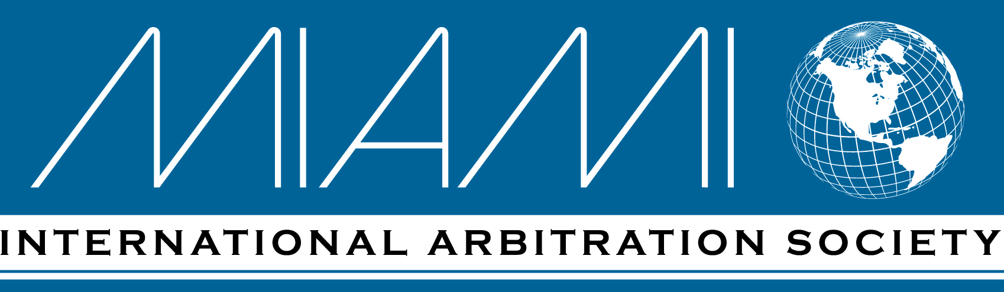
Luis O’Naghten
Chairman
Baker McKenzie

Carlos F. Concepción
Past Chair
Shook Hardy Bacon LLP

Cristina Cárdenas
Past Chair
Reed Smith

Burton A. Landy
Founding Chairman
Harper Meyer

José I. Astigarraga
Director Emeritus
Reed Smith

John H. Rooney, Jr.
Vice-Chairman
J. Rooney Law

Rudy Pittaluga Jr.
Treasurer
Deloitte Advisors LLP (ret.)

Judith A. Freedberg
Director of Programs
ICCA Publications

Adolfo Jimenez
Director-Secretary
Holland & Knight

Donald J. Hayden
Director-Secretary
Mark, Migdal & Hayden

C. Ryan Reetz
Director
Bryan Cave Leighton Paisner LLP

Daniel E. González
Director
Hogan Lovells US LLP

Raoul G. Cantero
Director
White & Case LLP

Quinn Smith
Director
GST LLP

Joseph Matthews
Director
Joseph M. Matthews P.A.

Richard Lorenzo
Director
Hogan Lovells US LLP

Deborah B. Mastin
Director
Law Office of D. B. Mastin

Edward Mullins
Director
Reed Smith

Academic Members
Manuel A. Gómez
College of Law, FIU
Sandra Friedrich
Intl. Arbitration Institute
University of Miami
Joan Stearns Johnsen
Levin College of Law
University of Florida

_________

By E-mail: uncitral@un.org January 23, 2020

UNCITRAL Secretariat
Vienna International Centre
P.O. Box 500
A-1400 Vienna, Austria
Re: UNCITRAL Working Group II (Dispute Settlement)
Seventy-first session
New York, 3-7 February 2020
Dears Sirs or Mesdames:
The Miami International Arbitration Society (MIAS) was founded in order to promote the use of international arbitration and mediation and the selection of Miami as the situs for international arbitration proceedings related to the resolution of transborder commercial and investment disputes. MIAS is honored to have been invited to attend the seventy-first session of Working Group II on “Issues related to Expedited Arbitration.” We will be sending delegates to the 3-7 February session in New York.
MIAS has reviewed the “Note by the Secretariat” containing draft expedited arbitration provisions. It asked its Task Force chaired by MIAS member, John M. Barkett, to review the draft provisions and questions posed in the Note by the Secretariat. The attached “Report of the Task Force on Issues Related to Expedited Arbitration in connection with the UNCITRAL Rules to be considered at the Seventy-first Session of UNCITRAL Working Group II” represents the current work product of the Task Force. On behalf of MIAS, I wanted to share the MIAS Task Force Report with the Secretariat in the hope that it will advance the dialogue of Working Group II.

Sincerely,

Luis O’Naghten
Chairman
MIAS Board of Directors

Enclosure

